1. **Create an Canvas elements with the following: Convert alternate bar to linear gradient.**



1. **Create an SVG element and draw the following**

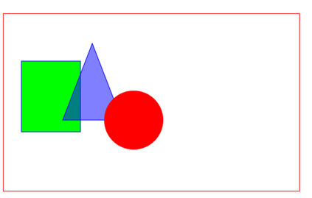

**Use circle, rectangle, Polygon and ellipse to implement the execution.**